Center Information:
Date: November 18, 2021
Name of Center Director: Anna Sediva
Name of Institution:
Department of Immunology, 2nd Faculty of Medicine, Charles University, and Motol University Hospital, Prague
City/Country: Czech Republic

Progress and Updates:

Educational Activities:
- Grand Rounds
- Regular pre- and post-graduate teaching, expanded curriculum of
- primary immunodeficiencies for undergrad students, including interactive courses both in the laboratory and clinical settings
- Regular weekly ground-rounds held in the Department of Immunology, to discuss case reports, open to all University Hospital departments and nationwide for cooperating network
- Symposia
- Regular Spring School in Primary Immunodeficiencies, last one in 2019, Kutná Hora, Czech Republic. Canceled due to the COVID-19 pandemic in 2020, still planned in the end of November in 2021.
- CME Conferences
- Regular participation in national conferences, in 2021 Pediatric congress with international participation, very well attended and valued session on Primary Immunodeficiencies. An occasion to introduce SCID screening program planned to launch in January 2022, to pediatric community. CME accredited event.
- Educational day for national Association of Physicians, CME accredited, June 2021.
- Yearly congresses of the Czech Society for Allergy and Clinical Immunology. Our JMF center is chairing national Immunodeficiency Interest group working within the society and is responsible for the Immunodeficiency Sessions program.
- Physician Education Materials – Translation and Printing – including 10 Warning Signs
- Novel release of the 3rd edition of a book Immunodeficiencies, completely reworked book with the latest knowledge
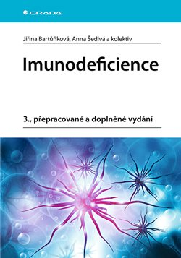

- 10 warning signs - translated and widely distributed
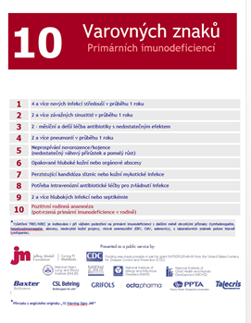
- Regular meetings of the Immune Interest Group, the last one in September 2021, Hradec Králové

- Webinars
  - Expanded curriculum of primary immunodeficiencies for undergrad students, including a interactive quiz-based case-solving workshop
  - Participation at ESID Journal Club (scheduled Feb ‘22)
  - T cell workshop (Oct ‘21, for the Academy of Sciences)

Patient Support:
- Patient Registry Participation
- Participation in the national Registry of Primary Immunodeficiencies, the largest center in the country
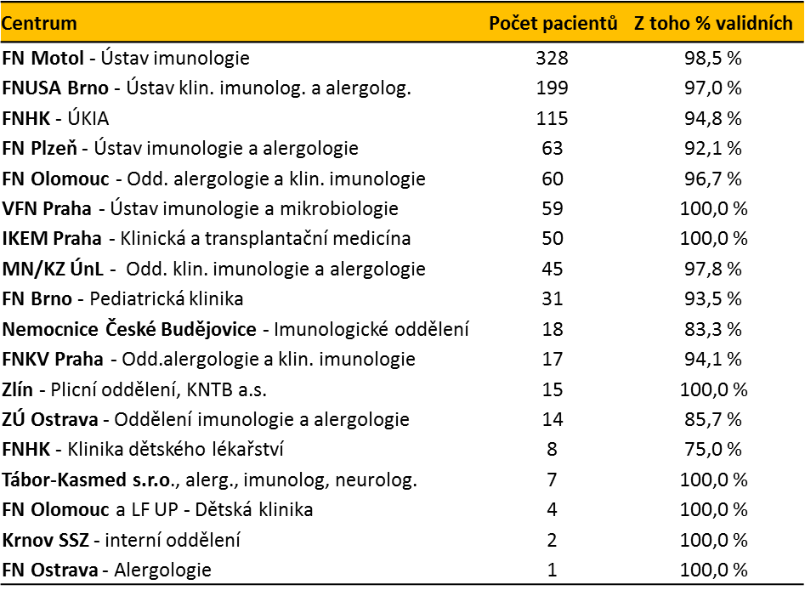

- Participation in the ESID registry
- Revision of the whole registry in line with GDPR rules, 2020,2021
- Interaction with Patient Organization
- Czech Association for Rare Diseases, responsible for Inborn Errors of Immunity, https://www.vzacna-onemocneni.cz/
- Imuníci, novel patient´s organization established September 2019, activities influenced by COVID-19 pandemic, https://www.imunici.cz/
- Patients association for Hereditary Angioedema, very active society, https://haejunior.cz/
- thymic tx patients working together with GOSH to create booklets and information materials for parents of future patients who undergo thymic tx @ GOSH (via Zoom interviews, questionnaires)

- KIDS Days
- Last in 2019, during PID week, together with patients, planned after the end of pandemic
- Website
- www.imunodeficience.cz
- https://imunologie.lf2.cuni.cz/en/research/workgroups/immunodeficiences

Research:
- Collaborative Studies
- Grant of the National Grant Agency, Modern approach to the field of primary immunodeficiencies: translating precise molecular and functional diagnosis to therapy, 2017-2022, national co-operation coordinated by our JMF center
- Participation on CHGE
- GOSH London, diGeorge syndrome
- Center for Chronic Immunodeficiencies Freiburg, Germany, research studies

- Protocols Overview
  - Functional studies in patients with PIDs, cytokine responses, signaling pathways activation and functional tests, especially in patients with rare mutations (Lyn kinase, MDA5, STAT1 LOF, GOF, XIAP, others
- Specific Aims
  - Innate immunity in patients with STAT1 GOF, supported by JMF grant
  - APDS, clinical trials with specific inhibitor
- Objectives Achieved
- Personalized improved care of patients, published data – list of manuscripts
- Published Manuscripts
- https://imunologie.lf2.cuni.cz/en/research/publications
- List of publications based on our research programs is attached in “Other” section.

World Primary Immunodeficiency Week:
- Global Balloons & Bubbles Launch – Coordination with Local Patient Groups
- Last 2019, 2020 and 2021 on-line due to the COVID-19 pandemic
- Media Outreach
- TV, radio, newspapers, social media, on-line media for public and professionals
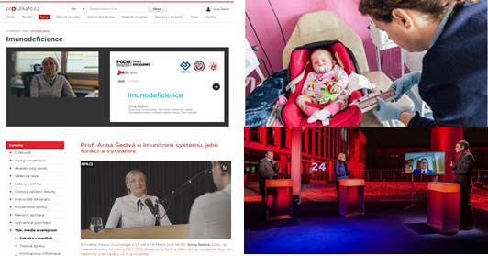

- Government Outreach
- Ministry of Health, committee for Rare Diseases, centers for special care, European Reference Network for Primary Immunodeficiencies

- Senate of the Czech Republic – screening SMA+SCID, since January 2022

- Future Goals:
- SCID screening since 2022
- Support of Patient´s organization
- Further national and international grant applications
- Support of junior colleagues
- Ongoing registry activities, projects based on registry data

- Activities planned for next budget period
- All of the above
- Ongoing activities – registries, patient´s organization, PID week, patients and kids meeting, research activities, junior activities
- The main goal for 2022 and beyond: SCID screening program

Other:
Publications, JMF center Motol University Hospital
2019-2021

Accelerated Maturation, Exhaustion, and Senescence of T cells in 22q11.2 Deletion Syndrome. Smetanova J, Milota T, Rataj M, Bloomfield M, Sediva A, Klocperk A.J Clin Immunol. 2021 Oct 29
Immunogenicity and Safety of COVID-19 mRNA Vaccine in STAT1 GOF Patients. Bloomfield M, Parackova Z, Hanzlikova J, Lastovicka J, Sediva A.J Clin Immunol. 2021 Oct 31:1-4.
High Prevalence of Likely Passively Acquired Anti-TPO and Anti-GAD Autoantibodies in Common Variable Immunodeficiency. Tomas M, Karel K, Petr L, Iveta K; PID Clinical Group.J Clin Immunol. 2021 Nov 15.
Natural Course of Activated Phosphoinositide 3-Kinase Delta Syndrome in Childhood and Adolescence. Bloomfield M, Klocperk A, Zachova R, Milota T, Kanderova V, Sediva A.Front Pediatr. 2021 Jul 19;9:697706

Mutual alteration of NOD2-associated Blau syndrome and IFNgammaR1 deficiency. Parackova Z, Bloomfield M, Vrabcova P, Zentsova I, Klocperk A, Milota T, Svaton M, Casanova JL, Bustamante J, Fronkova E, Sediva A.J Clin Immunol. 2020 Jan;40(1):165-178

Bronchial Asthma and Bronchial Hyperresponsiveness and Their Characteristics in Patients with Common Variable Immunodeficiency.Milota T, Bloomfield M, Parackova Z, Sediva A, Bartunkova J, Horvath R.Int Arch Allergy Immunol. 2019;178(2):192-200

Acquired Angioedema with C1 Inhibitor Deficiency: Occurrence, Clinical Features, and Management: A Nationwide Retrospective Study in the Czech Republic Patients.Sobotkova M, Zachova R, Hakl R, Kuklinek P, Kralickova P, Krcmova I, Hanzlikova J, Vachova M, Bartunkova J.Int Arch Allergy Immunol. 2021;182(7):642-649

Lymphoproliferation, immunodeficiency and early-onset inflammatory bowel disease associated with a novel mutation in Caspase 8.Kanderova V, Grombirikova H, Zentsova I, Reblova K, Klocperk A, Fejtkova M, Bloomfield M, Ravcukova B, Kalina T, Freiberger T, Sediva A. Haematologica. 2019 Jan;104(1):e32-e34

Novel SAMD9 Mutation in a Patient With Immunodeficiency, Neutropenia, Impaired Anti-CMV Response, and Severe Gastrointestinal Involvement. Formankova R, Kanderova V, Rackova M, Svaton M, Brdicka T, Riha P, Keslova P, Mejstrikova E, Zaliova M, Freiberger T, Grombirikova H, Zemanova Z, Vlkova M, Fencl F, Copova I, Bronsky J, Jabandziev P, Sedlacek P, Soukalova J, Zapletal O, Stary J, Trka J, Kalina T, Skvarova Kramarzova K, Hlavackova E, Litzman J, Fronkova E. Front Immunol. 2019 Sep 18;10:2194

Novel XIAP mutation causing enhanced spontaneous apoptosis and disturbed NOD2 signalling in a patient with atypical adult-onset Crohn's disease. Parackova Z, Milota T, Vrabcova P, Smetanova J, Svaton M, Freiberger T, Kanderova V, Sediva A. Cell Death Dis. 2020 Jun 8;11(6):430

